PROJECT MANAGEMENT PLAN

***Healing Pawl Veterinary Hospital***



**Revision History**

|  |  |  |  |
| --- | --- | --- | --- |
| **Version**  **Number** | **Description** | **Date Modified** | **Author** |
| 1.0 | Finish Management Plan | 2020/5/31 | Li Jiadi |
| 2.0 | Integrated Management Plan | 2020/6/5 | Li Jiadi |
|  |  |  |  |
|  |  |  |  |

**Authority Signatures**

The Project Lead (Business Side) and the Project Manager agree to deliver the Delivery Stage of this project in accordance with this project management plan and amend it periodically as project parameters change.

|  |
| --- |
| Prepared by:_____LI JIADI_______________________________________________________  Signature  Please print:__________LI_JIADI______________________________________________________________  Name ID Date |
|  |

|  |
| --- |
| Approved by: _______Zhang XIAO DAN____________  Signature  Please print: ____________________________________________________________________  Name Title Date |

**Table of Contents**

1 Executive Summary 5

2 Integration Management 5

2.1 Project Team Structure 7

2.2 Roles and Responsibilities 8

2.3 Change Management 9

2.3.1 Change Control 10

2.4 Project Close Out 10

3 Scope Management 11

3.1 Scope Statement **错误!未定义书签。**

3.2 Requirements Management 12

3.3 Project Deliverables 12

3.3.1 Work Activities 13

3.3.2 Constraints 13

3.3.3 Assumptions 14

3.3.4 Stakeholders 14

4 Schedule Management 14

4.1 Milestones 15

4.2 Schedule Control 15

5 Cost Management 18

5.1.1 Estimation 19

5.1.2 Budget Allocation 21

5.1.3 Budget Control 21

6 Quality Management 23

6.1 Quality Assurance 23

6.2 Quality Control 24

7 Human Resource Management 24

7.1 Human Resources Acquisition 25

7.2 Human Resources Development 25

8 Communications Management 26

8.1 Stakeholder Analysis 26

8.2 Project Reporting and Communication 27

9 Risk Management 28

10 References 28

# Executive Summary

## Project Establishment Motivation

Healing Paws Veterinary Hospital, our customer company, supports professional treatments to the dogs and cats. As the result of increasing volume of customers and requirements to increase efficiency, the administrator in Healing Pawls want to migrate related service from traditional paper-based workflow to the cloud based application for mobile access and online processing.

Specifically, the web application should consists of two ports the customer port comprising making pets appointments online, preserving pet information and tracking the treatments status, as well as the employee ports in which employee can track, process and prioritize the orders. Beside, the system should give an adaptation to various devices and screen size.

## Problem demonstration and System Design

According to the requirements from the healing paws veterinary hospital, we propose our solutions to realize the bast value after prudent system design. In general, our application should be able to:

1. Integrate the separated services into a comprehensive system.
2. Establish a statistics calculation diagrams for directly demonstrating income data for enhanced on efficiency.
3. Online consulting service in a transparent manner

Under these premises, we have designed more specific mechanisms to meet user experiences, profit maximization and technical objectives and encapsulating the core requirements of the Healing Pawl Veterinary service.

**Integrate separated service and products into a comprehensive system.**

The system provides multiple pets treatment services varying in making appointments, tracking and also consulting services. Humanized and flexible choice and designed to satisfy multifarious requirements.

Typically, a customer who apply for a pet treatments service are suggested to leave their contact details to be notified with the treatment stages and be kept as a recording identification. By the migration to the electronic form of service, the customers can easily get notification as well as enhanced convenience on their general operation. The system previous users ability to ask for consultant service online and also access their pets states.

**Statistics calculation diagram of income**

Aiming to improve the decision-making phrase, the system should take its system as an advantage to show statistics results for a period. Past data summary can be used to prepared as an evidence for future decision making. An electronic dynamic websites statistic will help the staffs to make judgements to facilitate their work.

**Online consulting service in a transparent manner**

Traditionally, the customers generally contact with the veterinary hospital by telephones or face-to-face. In our system, if a customer decides to ask for a help, there should be online chatroom for people to ask for online help. In this form, it eases the communication between the staffs and the customers.

## Feasibility Assessment and Implementation Plan

In this section, we will evaluate the above four mechanism interm of feasibility taking technical implementation into consideration.

**Integrate separated service and products into a comprehensive system**

This function is feasible, and we plan to realize it with additional design listed as below.

* Front-end: Tables for individual products displaying related information
* Database: tables recording product information
* Operations: Encapsulated operations API.

**Statistic calculation diagrams**

This function is feasible, and we plan to realize it with additional design listed as below.

* Front-end: A web page for display the diagram, diagram-library from JQuey
* Black-end: Three independent API gateways to process these logics individually.
* Database: Three or four extra tables to store orders type, income data separately.

**Online consulting service in a transparent manner**

This function is feasible, and we plan to realize it with additional design listed as below.

* Front-end: A responsive layout for chatroom to fit for various devices.
* End-end: A Websocket API to handle the messages.
* Database: One table for the messages, and one table for the user account.

## Quantitative and Measurable Objectives

In this section, we will list out s set of quantitative, at least measurable objectives fulfilling both functional

and non-functional requirements. Functional requirements can be judged via detailed descriptions of operations, while non-functional requirements can be judged through quality attribute scenarios.

### Functional Requirements

This web application should satisfy functional requirements from Healing Paws Veterinary Hospital.

* Ability for customers to make appointments for their pets. There are two appointment types:

emergency and standard. These will need to be handled by Healing Paws employees accordingly. It should be possible for one customer to make appointments for multiple pets if possible.

* Ability for customers to see the status of their pets for serious cases when required. For instance, surgery date confirmed, surgery complete, pet ready for release, etc.
* Ability for employees to organize, prioritize and keep track of pets in the system.
* Ability for customers to ask questions and for employees to answer them.
* The system should have two portals – one for customers and one for employees.

### Non-Functional Requirements

Additionally, this system should retain excellent performance in terms of non-functional requirements,

* Cloud-based
* Web-accessible
* Secure
* Reliable
* The ability for user and employees to interface with the new solution in English or Chinese

# Integration Management

When carrying out project management, no matter which process or stage, we should not only focus on the parts, but also integrate the overall management idea into all aspects of project management. Also, we should focus on analyzing and solving problems from the overall perspective of the project.

The purpose of integrated management is to integrate all plans, coordinate all aspects, and integrate sub-areas such as scope management, time management, quality management, so as to make them conform to the overall goal of the project.

## Project Team Structure

In this project, teacher is responsible for the module, my project team and teacher are involved in the approval process.

Our teachers act as the customer. Our developing group leader communicate with them via emails, meeting and reposts. The teachers are also the sponsor who we communicate with in class.

Our project manger is teacher assistant Yao. The TA attend our weekly meeting, report our process to teachers and convey our problems to them.

We have a team leader to coordinate and manage various affairs, and user group to give feedback of the system. More detailed team structure is illustrated in the image below.

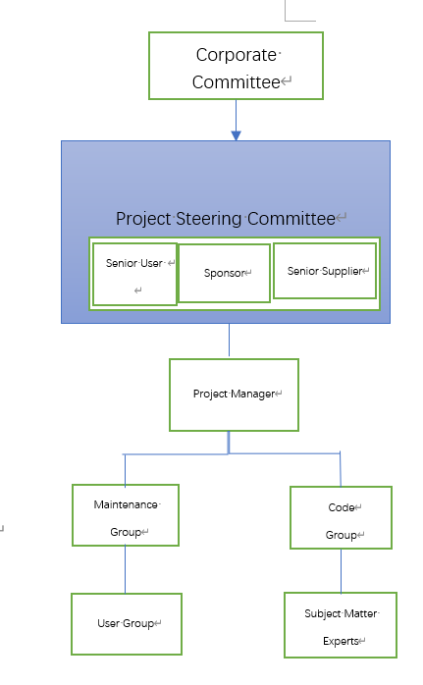

Figure 1 Project Team Structure Diagram

## Roles and Responsibilities

|  |  |  |  |
| --- | --- | --- | --- |
| Project Position | Name | Responsibilities | External resource |
| Corporate Committee | Dr. Catherine Mooney  Dr. Becker Brett | Represent Healing Paw Veterinary Hospital | No |
| Senior User | Other groups | Testing |  |
| Sponsor | Dr. Catherine Mooney  Dr. Becker Brett | Give support for the project |  |
| Project Manager | Teaching Assistants | Report our process and convey our problem to teachers |  |
| Team Leader | Li Jiadi | Write **Executive Summary , Quality Management and Project Team Structure Diagram** in Management Plan |  |
| Group Member | Yao Xinyao | Write **Integration Management , Communication Management** in Management Plan |  |
| Team Leader | Yang Shiyuan | Write **Schedule Management, Human Resource Management** in management plan |  |
| Team Leader | Wu Xiulin | Write **Cost Management ,Risk Management** in Management plan |  |
| Team Leader | Wang Xienan | Write **Scope Management** in Management Plan |  |

## Change Management

*Step 1: Change Request*

*Change applicant ---* Request for change

Reporting --- change request form

*Step2: Change Assessment*

Change evaluator (Project steering group) --- evaluate the change

Reporting --- Change evaluation form

*Step3:Chane approval / denial*

Change Control Board (CCB) --- making decision

* Technique --- Majority
* Reporting --- Change confirmation

*Step4: Change implementation*

Change agent --- implement the change

### Change Control

* *Change governance*

This is the process to firstly decide if there should be a change.

The project manager approves the change request. If necessary, the Change Control Board(CCB)

is responsible for approving or rejecting the change request.

* *Change identification and request management*

Identify the change that should implement. These changes should meet the project requirements.

* *Impact analysis*

Assess the impact of the changes and be prepared to face the risks.

* *Change approval process*

Relevant personal and departments actually implement the change in this step.

* *Change tracking*

Follow up after the implementation of the change to ensure timely and effective response to any

Problems that may arise.

## Project Close Out

1. Staff reassignment plan

After the project is delivered and completed, the project team members will move onto other projects and continue with other work.,

A number of members will also remain on the project, responsible for subsequent customer service and maintenance.

1. Archiving project materials

Final confirmation and filing of all documents (for example, the contracts) generated during the project.

1. Post-mortem debriefings of project personnel

Summary project performance and feedback to every member in the project team.

1. Final report

Identify whether the project has achieved the objectives, and if it meet the requirements of sponsor, user, programmers, etc. Summarize the problems and solutions happen during the whole project. Document both good and had solutions to learn from.

# Scope Management

## Scope Statement

### Product Scope

The product scope includes the features and functions of the system. It can be divided into following parts:

* 1. **Account management**

**Register/Login System**

This system allow user to register their own accounts; each user has a different username, ID and password, corresponding to different policy data. This system allows user to login by their personal account.

**User module**

User are able to view and change personal information here. And edits their own identification details with phone number, e-mails and username/ID.

* 1. **Authentication management**

**Access control**

User accounts and the employee accounts have separated authority to access the user interface.

* 1. **Order management**

**Order creation**

This function supports clients to create their treatment orders with relating description, status, type of the pets and surgery executor.

**Order tracking**

This function supports the employees and also the clients to track the states of an order, beside the employee has abilities to change the order status and give some feedback.

* 1. **Consultant service**

**Consultant room**

This function supports the user to chat with an employee online and get some intime feedback form the employees who are in “Working” state.

**Message board**

This function supports the user to leave some messages for the employees to reply later to deal with the situation when the user is not in their “position”.

### Product Scope

| Activities In Scope | Activities Out of Scope |
| --- | --- |
| Collect an analyze requirements | Consider extreme and personalized requirements |
| Define Scope | Add additional functions and modules for the current version |
| Create WBS and plan milestones | Changing the members in the project group |
| Design tools: development language, tools, environment | Shorten the development time |
| Design the system architecture | Reduce the funds |
| Testing | Outcome a testing report |
| Maintenance | Use a time material mode |

## Requirements Management

### Requirement gathering

During the process of collecting requirement, we interviewed some staffs who are working in the healing paws veterinary hospital and some of them has some helpful suggestions on the electronic systems. We erect an webinar on Tencent Meeting and had a seminar about how to provide user and employees with better service experience and more efficient working tools respectively.

After the interview and seminar discussion, we classify the requirements and remove the extreme ones and those don’t correspond with the clients.

### Control Scope

Detailed regulations are made for controlling and monitoring the scope. Each group will have speech on the weekly meetings to present their completed work in that week the task for the next week. The project manager will trace the status and progress of the project. Additionally, client will take part in the meetings to give timely feedback, which is also beneficial to manage changes the scope.

### Validate Scope

We set up an internal quality controlling group including representatives and our developers, which is responsible for checking if the deliverables are correct and the functions implemented are meeting the

quality requirements.

## Project Deliverables

| Deliverable | Recipients | Delivery Date | Delivery Method |
| --- | --- | --- | --- |
| Final requirements | Project steering group,  Development groups | 2020/3/10 | Documents |
| Front-end Architecture Design | PM, Front-end developing group | 2020/3/17 | Documents |
| Back-end Architecture Design | PM, Front-end developing group | 2020/3/20 | Documents |
| Server architecture design | PM, Back-end developing group | 2020/4/20 | Documents |
| Database Design | PM, Server developing group  Back-end developing group | 2020/4/25 | Documents, diagrams and  Package |
| Front-end UI design | PM, Server developing group,  Back-end developing group | 2020/4/30 | Documents and diagrams |
| Front-end code | PM, Front-end developing group | 2020/5/1 | Packages |
| Front-end code | PM, Integration group | 2020/5/2 | Packages |
| Back-end code | PM, Integration group | 2020/5/6 | Completed system |

### Work Activities

This work activities and relationships between are shown in following Work Breakdown Structure.

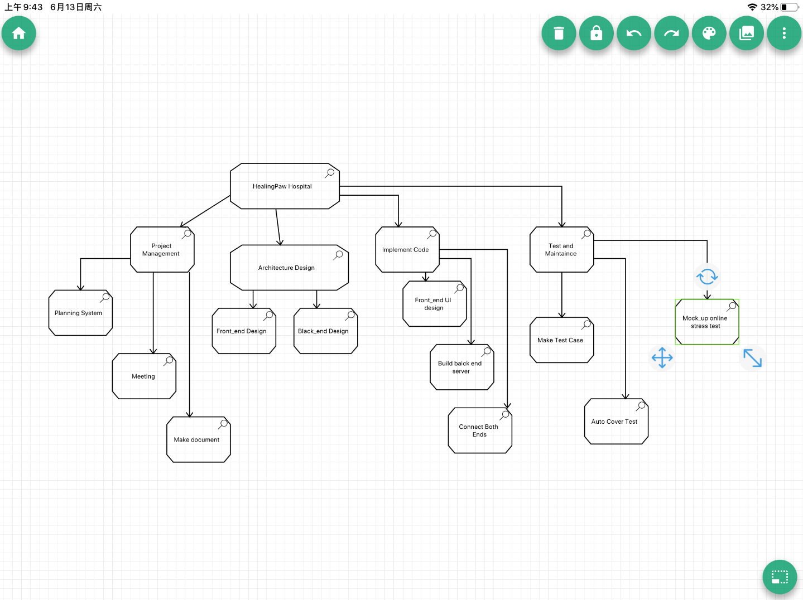

Figure 2 Work Breakdown Structure Diagram

### Constraints

**Hard Deadline**

As a mid-size project, our team has to develop the whole system within 11 weeks which is a tough constrain for each member.

**Deliverables**

In order to ensure the quality and scope to meet the requirements, every deliverable should be checked before further development, which really makes the project process more complicated and extend development time.

### Assumptions

All the volunteers attended in the interview and seminar give the helpful and valuable information which is beneficial to correct requirements; all the team members have all the skill required; all the team members can finish their task in time; some similar projects finish in time.

### Stakeholders

Healing Paw- Veterinary Hospital , all relevant staffs have attended this project group, all the participants in the requirements gathering works well.

# Schedule Management

Project schedule management refers to the scientific method to determine the schedule target, prepare the schedule plan and resource supply plan, carry out schedule control, and realize the schedule target on the basis of coordinating with the quality and cost target.The main goal of project progress management is to develop a reasonable and economical progress plan within the specified time, and then check whether the actual progress is consistent with the planned progress during the implementation of the plan, so as to ensure the completion of the project on time.

There are six phases in project schedule management: Define Activities, Sequence Activities, Estimate Activity Resources, Estimate Activity Duration, Develop Schedule and Control Schedule.

In this section, we follows clear steps to perform Schedule Management concerning this project.

**Define Activities**

Due to the large number of activities involved in the project, we defined 5 important **activities** for analysis:

1. Login and registration
2. Create treatment order
3. Change and create the personal information
4. Employees process the orders
5. Employees reply for the client questions

**Sequence Activities:**

We use the precedence diagrams method (PDM) to show the sequence of these activities.

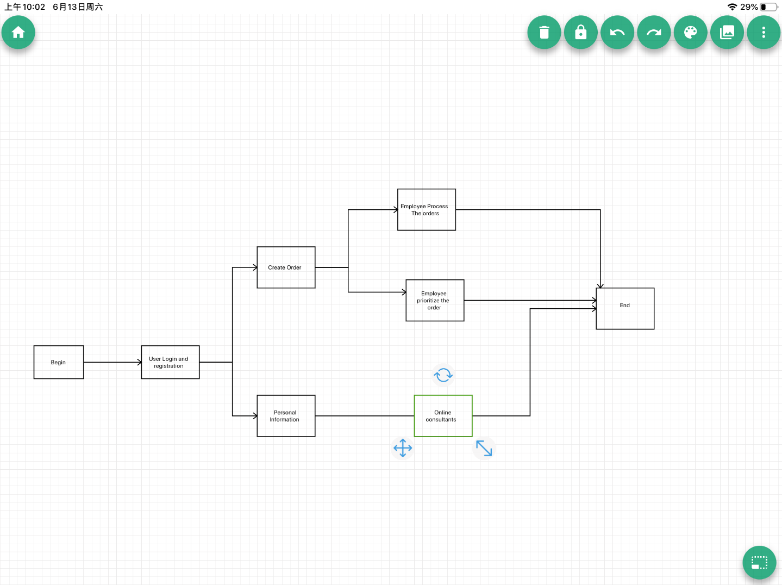

Figure 3 Precedence Diagramming Method

## Milestones

| **Description** | **Forecast Date** | **Gate / Approval** |
| --- | --- | --- |
| Complete the UI design | 2020/4/1 | 2020/4/2 |
| Complete the function of User Login and Registration | 2020/4/4 | 2020/4/5 |
| Complete the functions of Create Order and Fill in Personal Information | 2020/4/9 | 2020/4/10 |
| Complete the functions of that employees process and prioritize the orders | 2020/4/16 | 2020/4/17 |
| Complete the Consultants | 2020/4/25 | 2020/4/26 |
| Testing and optimizing | 2020/4/30 | 2020/5/1 |
| Complete the User document and system document | 2020/5/5 | 2020/5/6 |
| Final release | 2020/5/10 | 2020/5/11 |

## Schedule Control

### Measurement Mechanisms

In order to measure the progress of the work completed at milestones, we estimated the type and quantities of material, human resources, equipment, or supplies required to perform each activity.Then, we analyzed activity sequences, durations, resource requirements, and schedule constraints to create the project schedule model.

**Estimate Activity Duration**

We used Three-Point Estimating to analyze each activity, and provide their Most Likely (tM), Optimistic (tO) and Pessimistic (tP) values considering estimation uncertainty and risks. Then, we used Beta Distribution to calculate the expected duration (tE):

1. User Login and Registration

tM: 4 days

tO: 2 days – Front-end does not need to support user input validation.

tP: 5 days – Front-end submits user inputs to the back-end might fail

tE: 4 days

1. Create Order

tM: 4 days

tO: 2 days – Front-end uses normal HTML form format

tP: 5 days – Front-end submits user inputs to the back-end might fail

tE: 4 days

1. Fill personal information

tM: 5 days

tO: 2 days – Front-end uses normal HTML form format

tP: 6 days – A DropBox for avatars might fail.

tE: 5 days

1. Employee process the orders

tM: 6 days

tO: 5 days – Front-end uses normal HTML form format

tP: 8 days – Hard to achieve the AJAX method when developing the order form.

tE: 7 days

1. Consultant service

tM: 6 days

tO: 4 days – Front-end uses normal HTML form a Bootstrap Widget Library

tP: 7 days – Websocket possibly cannot handle the messages from the client sides

tE: 6 days

**Develop Schedule:**

We used critical path method (CPM) to estimate the minimum project duration and determine the amount of scheduling flexibility on the logical network paths within the schedule model:

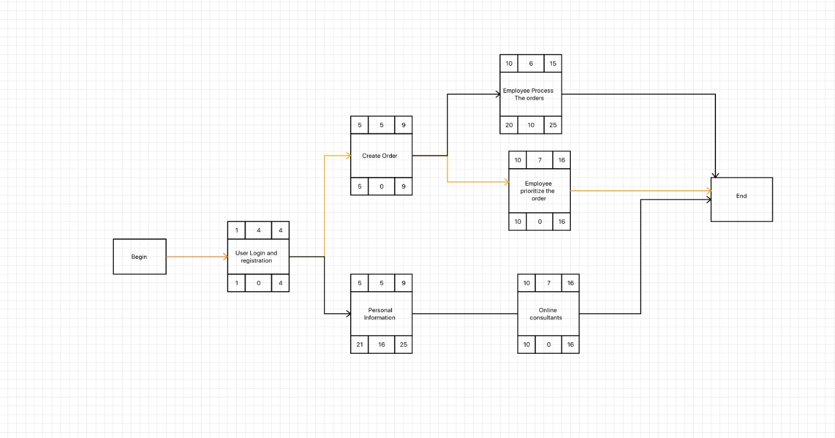

Figure 4 Critical Path Method

**Gantt Chart**

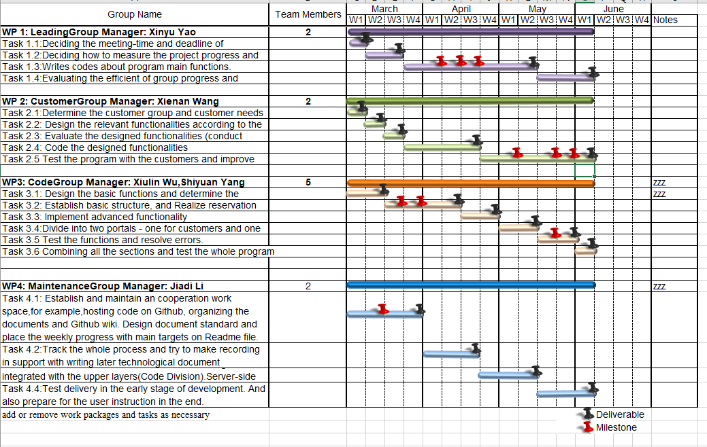

### Adjustment Schedule

**Buffers:**

1. Project buffer:

One buffer placed at the end of the critical chain.Protecting the target finish date from slippage along the critical chain.

1. Feeding buffers:

Buffers placed at each point where a chain of dependent activities that are not on the critical chain feeds into the critical chain.Protecting the critical chain from slippage along the feeding chains.

# 

**Resource Optimization Techniques:**

Techniques which are used to adjust the start and finish dates of activities to adjust planned resource use to be equal to or less than resource availability

1. Resource leveling:

A technique in which start and finish dates are adjusted based on resource constraints with the goal of balancing demand for resources with the available supply.It can be used when shared or critically required resources are only available at certain times, or in limited quantities, or over-allocated.

2. Resource smoothing:

A technique that adjusts the activities of a schedule model such that the requirements for resources on the project do not exceed certain predefined resource limits.

**Schedule Compression Techniques**

Techniques which are used to shorten or accelerate the schedule duration without reducing the project scope in order to meet schedule constraints, imposed dates, or other schedule objectives:

1. Crashing:

A technique used to shorten the schedule duration for the least incremental cost by adding resources. Crashing works only for activities on the critical path where additional resources will shorten the activity’s duration.

2. Fast tracking:

A technique in which activities or phases normally done in sequence are performed in parallel for at least a portion of their duration. It only woks if activities can be overlapped to shorten the project duration.

# Cost Management

## Estimation

Project estimation will include:

**Human resource**

* 5 software developers
* 1 project manager
* 1 project quality personnel
* 1 configurator

**Equipment management**

* 5 laptops
* 1 server

We will use one week to estimate whole project.

The manager of code group will report the need of human and device sources to the manager of software configuration monthly. Then the manager of software configuration group will calculate all cost and report to the manager.

The timing of the estimates:

|  |  |  |  |
| --- | --- | --- | --- |
| Name | Estimate Value | **Sum** | **Total** |
| 1.Login module |  | **8** |  |
| 1.1 Identification system | **4** |  |  |
| 1,2 Authority management | **2** |  |  |
| 2.Customer’s modules | **2** |  |  |
| 2.1 Create order |  | **4** |  |
| 2.2 Fill in pets information | **2** |  |  |
| 3.Employee’s modules | **2** |  |  |
| 3.1 Employee’s information |  | **6** |  |
| 3.2 Process order | **2** |  |  |
| 4.Consultant Service | **2** |  |  |
| 4.1 Websocket Api research | **2** |  |  |
| 4.2 API building and encapsulation |  | **4** |  |
| 5.Database | **2** |  |  |
| 6.UI | **2** |  |  |
| 7.Test |  | **8** |  |
| 8.Deploy |  | **8** | **38** |

From this, the overall budge can be roughly calculate as follow:

Assume: one man one day cost 1000 RMB

Task management + quality management = 30%

Development tasks = 62000 * 30% =18600RMB

Direct cost = 18600 + 62000 = 80600 RMB

Indirect Cost = direct * 30% = 24180 RMB

TOTAL = 80600 + 24180 = 104780 RMB

In this case we need one more server add 10000RMB =62390RMB

|  |  |  |  |  |  |
| --- | --- | --- | --- | --- | --- |
| **Stage** | **Allocation proportion** | **Workload**  **Man-days** | **Human**  **Cost** | **Other** | **Sum** |
| Login module |  | 8 | 4000 | 1000 | 5000 |
| Customer’s modules |  | 4 | 2000 | 1000 | 3000 |
| Employee’s modules |  | 6 | 3000 | 1000 | 4000 |
| Consultant Service |  | 8 | 2000 | 1000 | 3000 |
| UI |  | 8 | 2000 | 1000 | 3000 |
| Test |  | 4 | 2000 | 1000 | 3000 |
| Deploy |  | 4 | 2000 | 1000 | 3000 |
| Total |  | 42 | 17000 | 8000 | 24000 |

1. Most likely (cM) 42
2. Optimistic (cO) 80
3. Pessimistic (cP) 92
4. Distribution:
   1. Triangular Distribution cE = (cO + cM +cP)/3 = 71.3
   2. Beta Distribution cE = (cO+4cM +cP)/6 =56,6

### Budget Allocation

The monthly recurring includes with Human Resources and Travel costs.

Non-recurring includes with the cost of equipment and the training at the beginning of the project, the review activity at the end of the project.

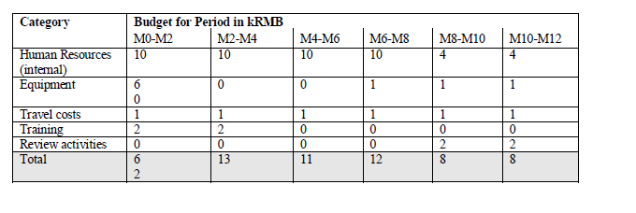

Diagram 1 The Budeget Baseline Diagram



### Budget Control

* Planed Value (PV)
* Earned Value (EV)
* Actual Cost (AC)
* Schedule Variance (SV) = EV(Earned Value) – Planned Value(PV)
* Cost Variance(CV) = EV – AC
* Schedule Performance Index (SPI) = EV/PV
* Cost Performance Index(CPI) =EV/AC

|  |  |  |  |  |  |  |  |  |
| --- | --- | --- | --- | --- | --- | --- | --- | --- |
| **Update time** | **Stage** | **Communicative Cost-to-Date** | | | **This week the statistics** | | | |
| AC | PV | EC | SV% | CV% | SPI | CPI |
| W1 | Login/Register Module | 8 | 8 | 8 | 0% | 0% | 1.00 | 1.00 |
| W2 | Customer’ s modules | 12 | 4 | 12 | 0% | 0% | 1.00 | 1.00 |
| W3 | Employee’s modules | 18 | 18 | 18 | 0% | 0% | 1.00 | 1.00 |
| W4 | Instant Message Service | 22 | 22 | 0% | 0% | 0% | 1.00 | 1.00 |
| W5 | Database | 30 | 30 | 30 | 0% | 0% | 1.00 | 1.00 |
| W6 | UI | 38 | 38 | 38 | 0% | 0% | 1.00 | 1.00 |
| W7 | Test | 42 | 42 | 42 | 0% | 0% | 1.00 | 1.00 |
| W8 | Deploy | 46 | 46 | 46 | 0% | 0% | 1.00 | 1.00 |

SV = CV = 0

SPI =CPI = 1.

In general, the budget is in line with the actual situation.

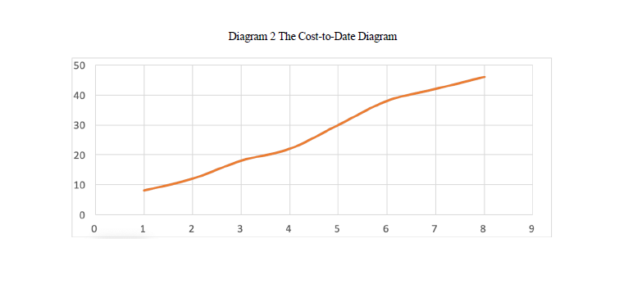

# 

# Quality Management

During the process of the project development, it is important to make sure that the quality of the project process and the project deliverable are satisficed with the customer and are of adequate quality and fit-for-purpose.

The following are the quality objectives of the project that reflect the overall intentions to be applied with regard to quality throughout the project.

1. The deliverable should be easy to use.

2. The deliverable should meet the requirements that the customer asked, including the report for the lost luggage, check and alter the personal information of the user, check the feedback from the employee end, register as a new user of the system, and employee can process the insurance request from the user.

3. Project practices conform to recommended project management standards

4. Deliverable should be multi-platform

The quality management plan identifies these key components

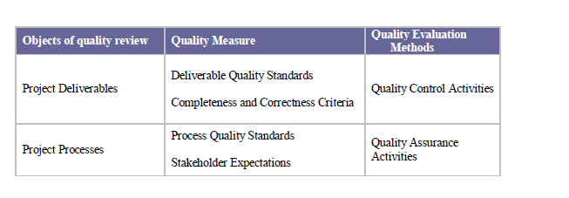

## Quality Assurance

The focus of quality assurance is on the processes used in the project. Quality assurance ensures that project processes are used effectively to produce quality project deliverable.

|  |  |  |  |  |
| --- | --- | --- | --- | --- |
| Project Process | Process Quality Standards | Quality Assurance Activity | Frequency | Responsible |
| Develop project chapter | Meet the requirements of the customer | After the project charter by each of the develop phase | Each project phase | Project manager |
| Execute and control project per project plan | Every functionalities  of the requirements should be met | Audit the following project activities   * Quality * Communications * Project progresss | Weekly  Monthly  Monthly | Whole team |
| Approve each project stage | 100% compliance with framework | Audit stage checkpoints | Once per project phase/stage | Whole team |
| Review software development practices of software application | Developers have completely and accurately captured application requirements | Peer review of software requirements specification | At regular intervals during the collection of requirements | Lead developer in conjunction with other knowledge developers |

## Quality Control

The focus of quality control is on the deliverables of the project. Quality control monitors project deliverables to verify that the deliverables are of acceptable quality and the customer is satisfied.

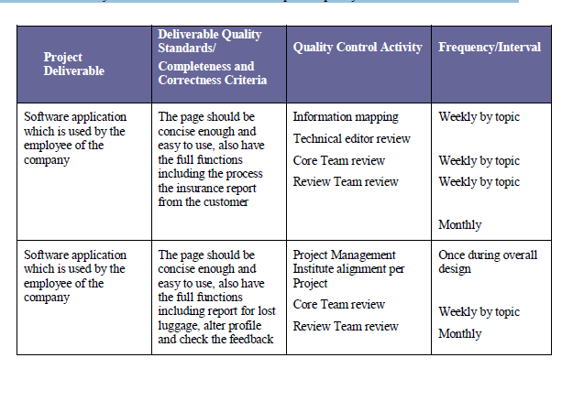

# Human Resource Management

In this project wo do not have many functional departments and it is impossible to add new functional department, so we do not need to warry about balance of resources every much. In addition, in this small project power division is clear, it will never be a problem and project manager’s leadership are not important.

Considerate the above reasons, I chose functional organization to plan the human resource management. Using this organization can guarantee resource supply and the quality of the project deliverables and the professionals are convenient for mutual exchange and mutual support to solve technical problems

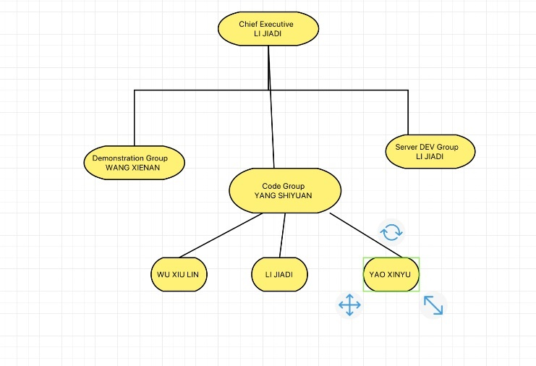

Figure 5 Team structure in software project group 15

### 7.1 Human Resources Acquisition

* Available Internal Candidates

### -Li Jiadi

-Skill: Requirement analysis, Python, Linux(sever)

-Date week1-week15

-Wang Xienan

-Skill: HTML, CSS, PR

-Date: week1-week15

- Yangshi Yuan

- Skill: Python

- Date: week1-week15

- Wu Xiulin

- Skill: Axure, latex

- Date: week1 -week15

- Yao Xingyu

- Skill: Python, JAVA

- Date: week1 – week15

- External Candidates: No external candidates

- Selection of Candidates and Assignments to Tasks

Li Jiadi: Take responsibility for communicating with customer and transfer it to requirement for all developer and take charge for the front-end design of android development.

Yang Shiyuan: Take responsibility for developing the framework for the application.

Wu Xiulin: Take responsibility for developing the prototype of the whole UI design and made database designing part.

Yao Xingyu: Take responsibility for developing the backend server, make sure the API can be used by all front end developer

Wang Xienan: Take responsibility for developing the backend server, make sure the API can be used by all front end developer; firm the demonstration and presentation video at the end of the project release.

* Availability and Duration of Assignment for all Candidates:

-As this a very small project so all candidate should take part in this project from the beginning to the end.

### 7.2 Human Resources Development

Project Specific Training

1. The first week all group member get a training about the knowledge about Git (SourceTree) so that make sure the version control is well done.

B. By the third week all group member should know how to make testing so that the whole programming can run successful. And learn the basic knowledge for their own work division.

II. Each week, the team should have a meeting to make sure each group member finish their own job in this week and determine the next week’s tasks. At the end of each weekends, members will in turn to make a code review and an weekly update journal.

# Communications Management

## Stakeholder Analysis

Through the analysis of the project charter and the business environment of the enterprise, we conclude that our stakeholders are:

1. Healing Paws Veterinary Hospital (Sponsor, internal)

Our client and key stakeholders, who is concerned about whether the project needs are met, whether the project quality is high, an whether the project benefits.

1. Customer of the hospital(external)

Client who use our system to track their pets treatments are the customer role in our stakeholder group.

1. Develop team (Internal)

The project development which is the implementer of the whole development, is mainly concerned with the quality and return of the project results.

Then there will be a potential analysis on the impact or supports each stakeholder will generate, classify them using the power interest grid and get result from it:



| Ser | How they will impact the project | How they will be impacted by the project | Communication Requirements |
| --- | --- | --- | --- |
| *Healing Paws Hosptial* | *Supportive, propose the main functional and non-functional requirements for the entire projects.* | *The quality of the project will directly affects the interest of the stakeholders* | Report the stakeholder at each end of the development phase, receive feedback from them and integrate new requirements. |
| *Customer of the Veterinary Hospital* | *Supportive, Provide non functional advice for the client end* | *Could affect their user experience* | Inform their advise about change within the user testing phrase in term their use. |
| *Develop team* | *Supportive, Directly affect the final product’s efficiency and qualitys.* | *Directly and affect their pay and workload* | Address the requirements of users to them update project document and get the current project status |

## Project Reporting and Communication

We have 4 kindof communications; the use and manner of each communication is shown in the table below.

| Type of Communication | Communication Schedule | Communication Mechanism | Initiator | Recipient |
| --- | --- | --- | --- | --- |
| *Weekly Meeting* | Every Tuesday | Group meeting with meeting agenda and minute | Project Manger | Project Team |
| *Meeting with sponsor* | Every day in mid-month | Delveriable’s acceptance test | Project manager | PM and Healing Paw Hospital |
| Meeting with user | At the first week of requirements gathering | Email and webinar | Project Manger | Requirements n lysis and future |
| As-needed communication | Anytime at weekdays | Emails and memos or group meetings | Project Tram member or PM | Project team |

# Risk Management

## Risk Plan Management

1. **Timing: every week risk management will be performed throughout the project life cycle**
2. **Risk categories: risk breakdown structure(RBS)**

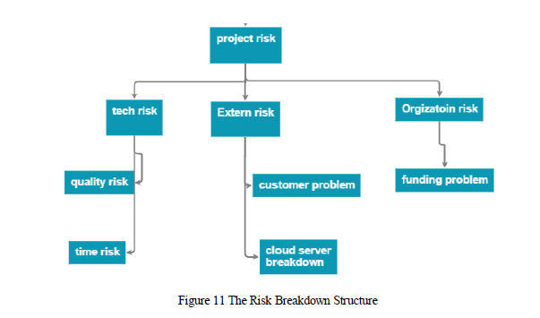

1. **Risk categories: risk breakdown structure(RBS)**

# 

## Identify Risks

A) Gather technique: Brainstorm and the Interviews, Root case analysis

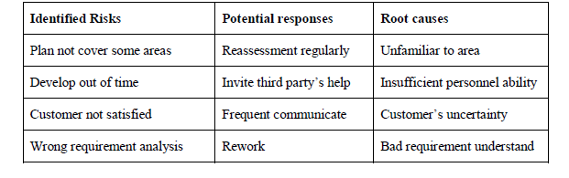

## Enform Qualitative Risk Analysis

1. Interviewing

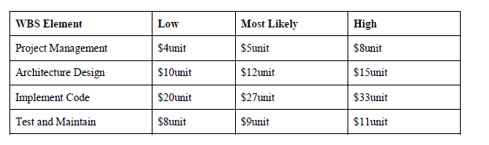

1. Sensitive analysis:

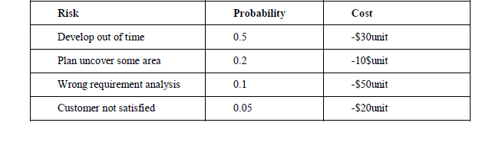

1. Expected monetary value analysis

Total EMV = $26unit

Our risk regisrer

|  |  |  |  |  |  |
| --- | --- | --- | --- | --- | --- |
| **Identified risk** | **Potential Response** | **Root Cause** | **Category** | **Priority** | **Urgency** |
| Plan not cover some | Reassessment regularly | Unfamiliar to area | management | low | Medium |
| Develop out of time | Invite third party’s help | Insufficient personnel ability | technical | medium | high |
| Customer not satisfied | Frequent Communicate | Customer’s uncertainty | human | low | Medium |
| Wrong Requirement Analysis | Rework | Bad requirement understand | technical | high | high |

## Enform Qualitative Risk Analysis

## Contingency plan:

1. Contingency plan:
2. Avoid : keep learn number up to plan to avoid uncertainty in projecy
3. Share: when some member has free time, help others when possible
4. Fallback plans
5. Transfer: when the develop out of the time, seek help from third part

## Control Risks

1. Risk reassessment regular every week reassess risk regisrter
2. Technical performance measurement compare performance with planned
3. Status meeting keep the team up to date on risk planning through project

# References

The following documents are attached to this Project Plan for immediate reference.

|  |  |  |  |
| --- | --- | --- | --- |
| **Appendix** | **Document Name** | **E-DRM # /Version** | **Date** |
| A |  |  |  |
| B |  |  |  |
| C |  |  |  |
| Etc |  |  |  |